"Silence in the Front Row"

The project "Silence in the Front Row" is part of my research on activist art and has been carried out as a field study in social and religious spaces. These spaces were chosen as one of the possible examples due to their unique characteristics, which play a significant role in fostering solidarity among individuals. They utilize sensory and multi-dimensional elements such as lighting, sound, imagery, color, and cultural symbols. These sensory and visual elements, in addition to their social impact, aid activist artists in better understanding the preferences and tendencies of their audience within familiar settings, enabling deeper engagement.

In this project, the results of my field studies have been visually represented through maps and interactive charts. These visualizations reveal the underlying and unspoken structures of solidarity and social contrasts present in religious spaces. At the conclusion of this research, key findings and insights from the project will be published. The aim is to inspire activist artists and provide them with innovative visual and conceptual approaches to engage effectively with their audience, fostering a more profound understanding of the needs and concerns of Iranian society in its engagement with activist art.

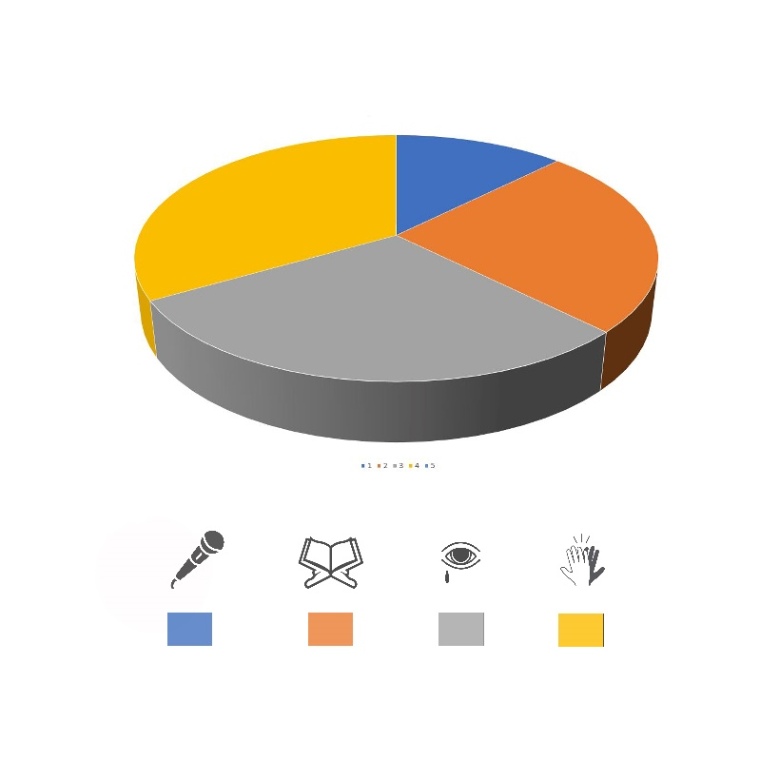

**Pie Chart of Interactions: This chart illustrates the various types of interactions among participants during the ceremony, showcasing the proportion and role of each type of engagement.**

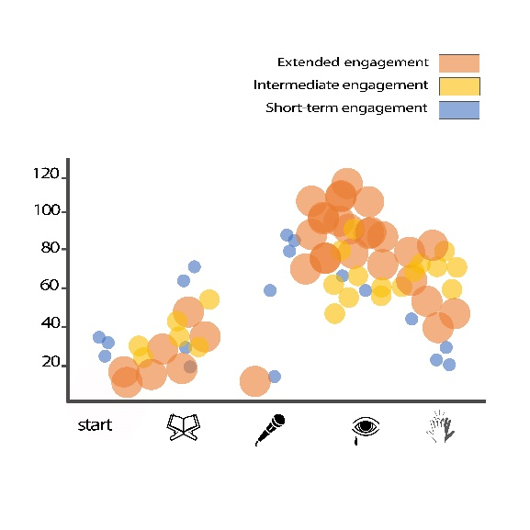

**Engagement Level Scatter Plot: This chart represents the level of participant engagement throughout the ceremony, categorized by interaction type and duration of presence, ranging from short-term to long-term. The use of diverse colors helps differentiate between various levels of engagement.**

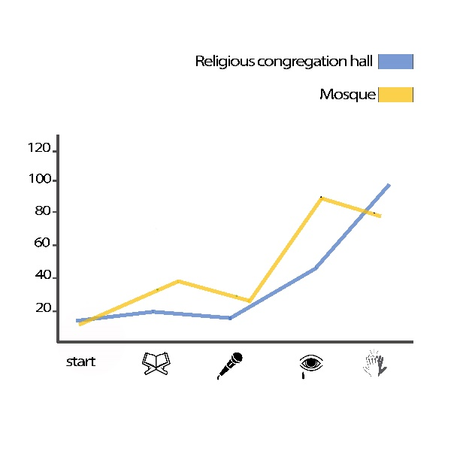

**Comparison Chart of Religious Spaces: This chart compares the level of interactions at two different locations during the ceremony, highlighting variations in audience engagement across these two spaces.**